NAME: XILUVA VANESSA MAVUNDA
STUDENT NO: EDUV4967470
MODULE: ITPNA-B12
LECTURER: S. RAMETSE.
SECOND BLOCK

Table of Contents
QUESTION 1 3
QUESTION 2 9
QUESTION 3 12

QUESTION 1

1.1
from http.server import BaseHTTPRequestHandler, HTTPServer
import json

class PreDepartureHandler(BaseHTTPRequestHandler):
def do_GET(self):
with open("pre_departure.json", "r") as file:
lines = file.readlines()
data = {}
for line in lines:
key, value = line.strip().split(": ")
data[key] = value
response = json.dumps(data)

self.send_response(200)
self.send_header('Content-type', 'application/json')
self.end_headers()
self.wfile.write(response.encode())

server = HTTPServer(('localhost', 8080), PreDepartureHandler)
print("Server started on port 8080")
server.serve_forever()
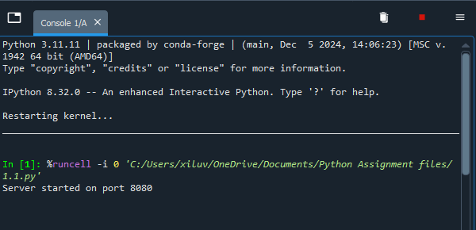

1.2
import requests

response = requests.get('http://localhost:8080')
data = response.json()
print("Pre-Departure Information:")
for key, value in data.items():
print(f"{key}: {value}")
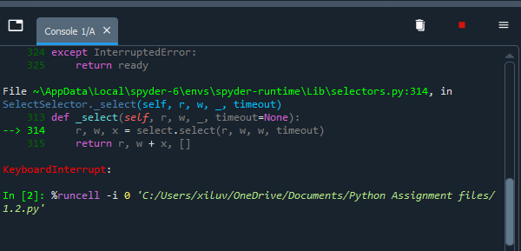

1.3
from http.server import BaseHTTPRequestHandler, HTTPServer
import json

class UpdateHandler(BaseHTTPRequestHandler):
def do_POST(self):
content_length = int(self.headers['Content-Length'])
post_data = self.rfile.read(content_length)

try:
update_data = json.loads(post_data.decode('utf-8'))

with open('pre_departure.json', 'r') as file:
current_data = json.load(file)

current_data.update(update_data)

with open('pre_departure.json', 'w') as file:
json.dump(current_data, file)

self.send_response(200)
self.send_header('Content-type', 'application/json')
self.end_headers()
self.wfile.write(json.dumps({"status": "success"}).encode('utf-8'))
except Exception as e:
self.send_response(500)
self.end_headers()
self.wfile.write(str(e).encode('utf-8'))

def run_update_server():
server_address = ('', 8001)
httpd = HTTPServer(server_address, UpdateHandler)
print('Update server running on port 8001...')
httpd.serve_forever()

if __name__ == '__main__':
run_update_server()
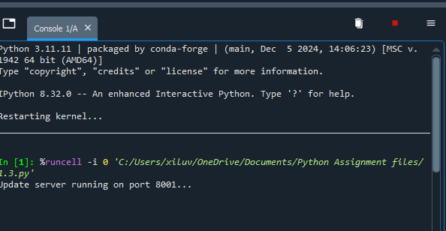

1.4
import json
import requests

response = requests.get("http://localhost:8082")
data = response.json()
print("In-Flight Events:")
for key, value in data.items():
print(f"{key}: {value}")
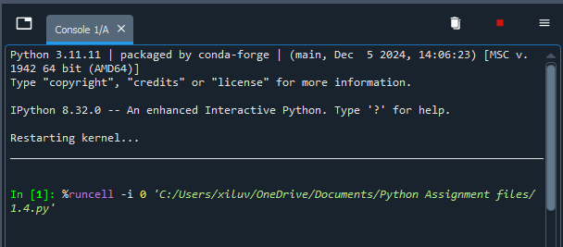

Server
from http.server import BaseHTTPRequestHandler, HTTPServer
import json

class InFlightHandler(BaseHTTPRequestHandler):
def do_GET(self):
with open("in_flight.json", "r") as file:
lines = file.readlines()
data = {}
for line in lines:
key, value = line.strip().split(": ")
data[key] = value
self.send_response(200)
self.send_header("Content-Type", "application/json")
self.end_headers()
self.wfile.write(json.dumps(data).encode())

server = HTTPServer(('localhost', 8082), InFlightHandler)
print("In-Flight server running...")
server.serve_forever()
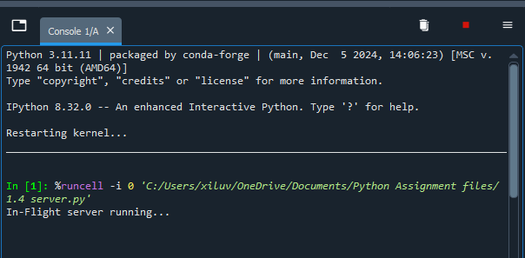

1.5
import json
import time

while True:
data = {
"Autopilot Status": "ON",
"Cabin Pressure": "Normal",
"Wi-Fi Usage": "High"
}

with open("in_flight.txt", "w") as file:
for key, value in data.items():
file.write(f"{key}: {value}\n")

print("In-flight info updated.")
time.sleep(5)
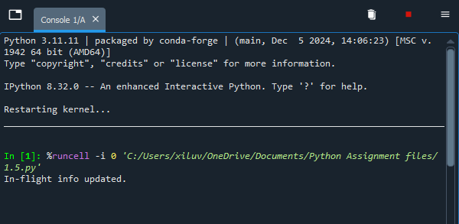

QUESTION 2

2.1 SMTP is used to send emails from a client to a server or between servers. It's a push protocol that does not save emails.
POP3 is used to receive email. It downloads emails from the server to the local PC and normally deletes them. It's easy, however it doesn't work well with different devices.
IMAP is also used to receive emails, however they remain on the server. It provides for cross-device syncing and folder management. It is more sophisticated than POP3, and it allows for multi-device access.
2.2 a)
import smtplib
from email.mime.text import MIMEText

sender = "your_email@example.com"
receiver = "receiver@example.com"
password = input("Enter your email password: ")

msg = MIMEText("Hello, this is a test email from Python!")
msg['Subject'] = "Python Test"
msg['From'] = sender
msg['To'] = receiver

with smtplib.SMTP_SSL("smtp.gmail.com", 465) as server:
server.login(sender, password)
server.send_message(msg)

print("Email sent!")

2.2 b)
import poplib
from email.parser import BytesParser
from getpass import getpass

server = poplib.POP3_SSL('pop.gmail.com', 995)
email = input("Enter your email: ")
password = getpass("Enter your password: ")
server.user(email)
server.pass_(password)

num_messages = len(server.list()[1])
print(f"Total Messages: {num_messages}")

for i in range(num_messages):
response, lines, octets = server.retr(i + 1)
message = BytesParser().parsebytes(b'\n'.join(lines))
print("Subject:", message['subject'])

server.quit()

2.2 c)
import imaplib
import email
from getpass import getpass

mail = imaplib.IMAP4_SSL("imap.gmail.com")
email_address = input("Enter email: ")
password = getpass("Password: ")

mail.login(email_address, password)
mail.select("inbox")

status, messages = mail.search(None, 'UNSEEN')
email_ids = messages[0].split()[:5]

for email_id in email_ids:
_, msg_data = mail.fetch(email_id, "(RFC822)")
raw_msg = msg_data[0][1]
msg = email.message_from_bytes(raw_msg)

subject = email.header.decode_header(msg["Subject"])[0][0]
if isinstance(subject, bytes):
subject = subject.decode()

print("Subject:", subject)

for part in msg.walk():
if part.get_content_type() == "text/plain":
print("Body:", part.get_payload(decode=True).decode(errors='ignore'))

mail.store(email_id, '+FLAGS', '\\Seen')

mail.logout()

2.4 IMAP stores emails on the server and synchronizes their status (read/unread, folders) across all devices. This implies that when a person reads an email on their phone, it will also be marked as read on their laptop.
POP3, by generally, downloads emails to one device and deletes them from the server, making them inaccessible on other devices. POP3 may be set to leave emails on the server, but it does not synchronize read/unread status or folder organization in the same way that IMAP does.
IMAP is better for a mobile user who checks email on different devices.

QUESTION 3

import smtplib
from email.mime.text import MIMEText
import json
import time

def check_safety_margins(data):
safety_margins = {
"Cabin Pressure": (850, 1100),
"Autopilot Status": "Engaged",
"Wi-Fi Usage": 80
}

alerts = []

if 'Cabin Pressure' in data:
pressure = data['Cabin Pressure']
if not (safety_margins["Cabin Pressure"][0] <= pressure <= safety_margins["Cabin Pressure"][1]):
alerts.append(f"Cabin pressure {pressure}hPa is outside safe range {safety_margins['Cabin Pressure']}")

if 'Autopilot Status' in data:
if data['Autopilot Status'] != safety_margins['Autopilot Status']:
alerts.append(f"Autopilot status is {data['Autopilot Status']}, should be {safety_margins['Autopilot Status']}")

if 'Wi-Fi Usage' in data:
usage = int(data['Wi-Fi Usage'].rstrip('%'))
if usage > safety_margins['Wi-Fi Usage']:
alerts.append(f"Wi-Fi usage {usage}% exceeds safe threshold {safety_margins['Wi-Fi Usage']}%")

return alerts

def send_alert_email(alerts):
sender = "monitoring@aeroairlines.com"
recipients = ["safetyteam@aeroairlines.com", "operations@aeroairlines.com"]
subject = "Aircraft Safety Alert"

body = "The following safety parameters are out of bounds:\n\n"
body += "\n".join(alerts)
body += "\n\nPlease investigate immediately."

msg = MIMEText(body)
msg['Subject'] = subject
msg['From'] = sender
msg['To'] = ", ".join(recipients)

try:
with smtplib.SMTP('smtp.aeroairlines.com') as server:
server.sendmail(sender, recipients, msg.as_string())
print("Safety alert email sent.")
except Exception as e:
print(f"Failed to send alert email: {e}")

def monitor_flight_events():
while True:
try:
with open('in_flight.json', 'r') as file:
data = json.load(file)

alerts = check_safety_margins(data)
if alerts:
print("Safety issues detected!")
for alert in alerts:
print(alert)
send_alert_email(alerts)
else:
print("All systems normal.")

time.sleep(10)
except FileNotFoundError:
print("In-flight data file not found. Waiting...")
time.sleep(5)
except Exception as e:
print(f"Monitoring error: {e}")
time.sleep(5)

if __name__ == '__main__':
monitor_flight_events()

